**CSE326**

**CSE Project**

**Project Title:**

**Indian Electricity website**

Project No. 05

(A Synopsis for Project of CSE 326)

**Submitted To: Manu Bali**

**D.O.S**: 11th April 2020

**Group Members:**

|  |  |  |
| --- | --- | --- |
| Name | Roll no. | Registration No. |
| Saurav kumar | 14 | 11908508 |
| Ashik A | 13 | 11908425 |
| Sadwik Naidu | 12 | 11908376 |

**ACKNOWLEDGEMENT**

I would like to express my Special thanks of Gratitude to my University as well as our CSE Faculty **Manu Bali** ma’am who gave us this opportunity to work on the project to “**Design a Website of Indian Electricity system”** which Also Helped me in knowing more things about this topic.

*Finally, I would like to thank my friends who helped me a lot in finishing this topic within a limited time.*

Thanks to All!

***

**INTRODUCTION: -**

The “Indian Electricity website” contains and manages the details of Indian electricity bill, consumption history, availability of new connection, availability of new services. It Contains the details of states that have high consumption record. It also contains the “pay your bill” option. This website is user friendly.

**Objective of the project: -**

The main Objective of the project is to manage the details of electricity bill, consumption history, availability of new connection, availability of new services.

The “Indian electricity website” has been developed to override the problems prevailing in the practicing manual system. This website is supported to eliminate or reduce the hardship faces by Indian electricity board. It is user friendly website and requires no formal knowledge to use. This can carry out operation in very smooth and effective manner.

It will provide a user interface that will be minimalistic and accessible at even slower internet speed and user will find it easy to access anything from website.

**Functionalities provided by Indian Electricity website are as follows:** -

* Provide recent news and updates regarding recent rate of electricity bill.
* It will allow the user to pay their electricity bill easily.
* Provides the facility to check the availability of nearest services.
* Provides facility to check availability of new electricity connection.
* Provides content about how to save electricity.

**FINAL REPORT ON “INDIAN ELECTRICITY WEBSITE”**

**INTRODUCTION**

The “Electricity Billing system” has been developed to override the problems prevailing in the practicing manual system. The software is supported to eliminate and in some cases reduce the hardship faced by this existing system. Moreover, this system is designed for the particular need of the company to carry out operations in a smooth and effective manner.

The application is reduced as much as possible to avoid errors while entering the data. No formal knowledge is required for user to use this system. Thus by this all it proves it is user friendly and fast management system, as described above, can lead to error free, secure, reliable and effective management system. It can assist the user to concentrate on record keeping. Thus it will help organization in better utilization of resources.

Every organisation, whether big or small, has challenges to overcome and managing the information of connection, electricity, bill, customer, payment. Every electricity billing system has different electrical needs therefore we design exclusive employee management system that are adapted to your managerial requirements. This is design to assist in strategic planning and will help you ensure that your organisation is equipped with the right level of information and details for your future goals. Also for those busy executive who are always on the go, our system come with remote access feature, which will allow you to manage your workforce anytime, at all times. This system will ultimately allow you to better manage resources. The “Indian electricity website” has been developed to override the problems prevailing in the practicing manual system. This website is supported to eliminate or reduce the hardship faces by Indian electricity board. It is user friendly website and requires no formal knowledge to use. This can carry out operation in very smooth and effective manner.

It will provide a user interface that will be minimalistic and accessible at even slower internet speed and user will find it easy to access anything from website.

It will provide a user interface that will be minimalistic and accessible at even slower internet speed and user will find it easy to access anything from website.

**Abstract of the project**

The purpose of electricity Billing system is to automate the existing manual system by the help of computerized equipment and full-fledged computer software, fulfilling their requirements, so that their valuable data/information can be stored for a longer period with easy accessing and manipulation of the same. The required software and hardware are easily available and easy to work with.

Electricity Billing system, as described above, can lead to error free, secure, reliable and fast management system.

It can assist the user to concentrate on their other activities rather to concentrate on record keeping. Thus it will help organization in better utilization of resources. The organization can maintain computerized records without redundant entries. That means that one need not to distracted by information that is not relevant, while being able to reach the information.

The aim is to automate the existing manual system by the help of computerized equipment and full-fledged computer software, fulfilling their requirements so that their valuable data information can be stored for longer period with easy accessing and manipulating of the same. Basically the project describes how to manage good performances and better services of the clients.

**Objective**

The main objective of the project on Electricity Billing system is to manage the details of Electricity, connection, Meter, Bill payment. It manages all the information about Electricity, customer, payment. The project is totally built at administrative end and thus only the administrator is guaranteed the access. The purpose of the project is to build an application program to reduce the manual work for managing the electricity, connection, customer, Meter. It tracks all the details about the meter, bill, payment.

The main Objective of the project is to manage the details of electricity bill, consumption history, availability of new connection, availability of new services.

The “Indian electricity website” has been developed to override the problems prevailing in the practicing manual system. This website is supported to eliminate or reduce the hardship faces by Indian electricity board. It is user friendly website and requires no formal knowledge to use. This can carry out operation in very smooth and effective manner.

It will provide a user interface that will be minimalistic and accessible at even slower internet speed and user will find it easy to access anything from website.

**Functionalities provided by Electricity Billing system: -**

* Provides the searching facilities based on various factors such as electricity meter, bill payment etc.
* Electricity Billing system also manages the customer details online.
* It tracks all the information of connection, customer, bill etc.
* Manage the information of connection.
* Shows the tips for how to save the electricity.
* Integration of information of Bill.
* Check the availability of nearest services.
* Check the availability of new connection.
* Stores the consumption history.
* User friendly website that require no formal knowledge.

**Screenshot of our website**

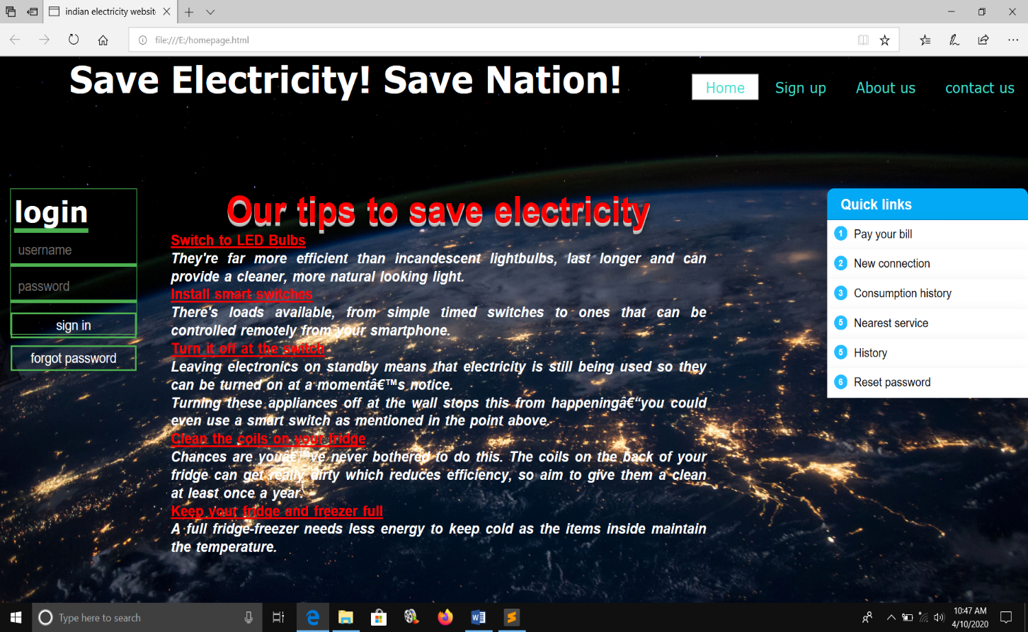

**LOGIN PAGE**

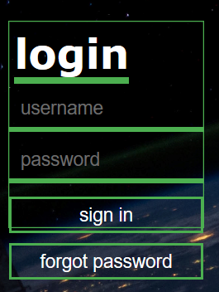

**Quick links page**

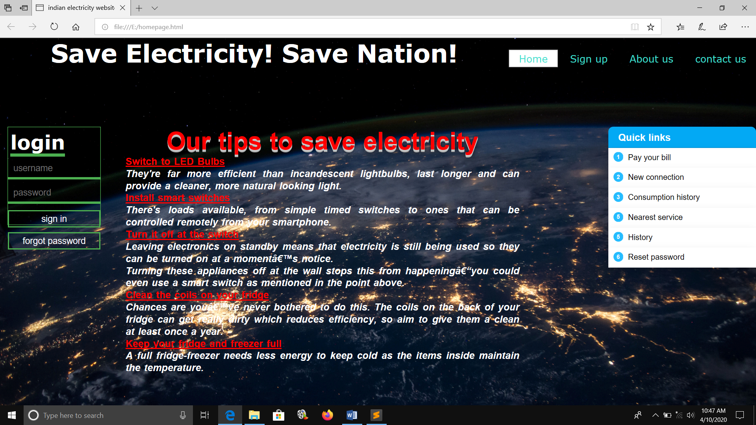

**Flow char of our website**

**Billing screen**

**HOME PAGE**

**Login page**

**customer**

**Login**

**Reports of Electricity Billing system: -**

* It generates the report on electricity, connection etc.
* Provides filter reports on meter, bill, payment.
* You can easily export pdf for electricity, customer, bill.
* Application also provides excel report on connection, meter, payment.
* You can also export the report into csv format for electricity, connection, bill payment history.

**Modules of Electricity Billing system: -**

* Electricity management module: used for managing electricity details.
* Payment Module: Used for managing details of payment.
* Customer module: used for managing details of customer.
* Meter module: Used for managing the meter details.
* Bill module: Used for managing the bill information.
* Login module: Used for managing the login details.
* User module: used for managing the user of the system.

**Group member’s role in this project**

* **Saurav kumar (11908508 roll-14): - design complete website and write synopsis and 80% of the final report.**
* **Ashik A (11908425 roll-13): - helps in writing synopsis and 10%of the report.**
* **Sadwik Naidu (11908376 roll no-12): - helps in writing synopsis and 10 % of the report.**